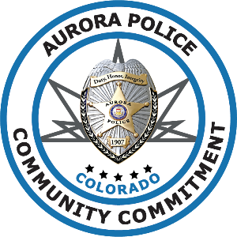
Class Registration for:

Officer Resiliency and Wellness
A Comprehensive Approach to a Healthy Career in Law Enforcement

Hosted by: The Aurora Police Department

Attendee’s Name: Click here to enter text.
Rank: Click here to enter text. N/A ☐
Agency: Click here to enter text.
Email: Click here to enter text. Phone: Click here to enter text.
Are you: ☐ Sworn or ☐ Non-Sworn

Training details:
Wednesday July 11, 2018 from 8:00 am to 4:30 pm
Professional Learning & Conference Center
15771 E. 1st Avenue, Aurora, CO 80011

Please complete this form and return it to: ehitchin@auroragov.org
For questions relating to this training, please feel free to call Emily Hitchings at 303-739-6007

